**HR & Manager Round Questions**

**Ques - Tell me about yourself?**

My name is Rahul Patidar, I am from Indore Madhya Pradesh India. I completed my Graduation in 2014 and after that I started my career in IT industry. I am having total 8 yr. of experience and totally in QA and fully comfortable in manual as well as automation testing.

Currently I’m working in Nuance India, where my roles and responsibilities are:

* Go through the requirement documents for assigned tickets.
* Prepare the test scenarios and test case and check the automation feasibility.
* Execute test case and write automation test if possible.
* Responsible for maintenance of automation framework.
* Participate in all scrum ceremonies.
* Participate in all tech talks!
* Participate in release process for multiple services.
* Regression end E2E test execution.
* Share the reports with the management.

**Ques - Tell me about your project? What challenges you faced? how you handled?**

Currently I’m working in Mix platform which is enterprise application and used to integrate with different application including banking, financial, insurance and other automotive machines and provide different type of services including TTS, ASR, NLU, DLG and companies can design flow as per their need.

**Challenges:**

* In Agile world, sometimes frequent changes of the requirement are bit difficult to manage.
* We need to take care of deadline.
* Sometimes we have to do quick releases and for that our regression and E2E suite be stable.
* We are using microservice architecture and in our E2E suite we are using multiple services and if any of the services is down then test case can create problem, so need to take care of this validation as well.

Follow **ATLC** for writing automation test

**ATLC (automation test life cycle)**

**1.Automation feasibility analysis**-  Which test case can be automated and how we can automate them. Also will check which test cases cannot be automate.

**2.Test plan and Design**- Fetch all the manual test case from test management tool that which TC has to automate. Which framework to use and what will be advantage and disadvantage of the framework which we will use.

**3.enviorment setup**-  What should be the configuration in terms of hardware and software.

**4.test script creation-**

* Start creating test script based on your requirement.
* Create some common method or function that you can reuse throughout your script.
* Make your script easy, reusable, well-structured and well documented so if third person check your script then he/she can understand your scripts easily.
* Use better reporting so in case of failing you can trace your code.
* Finally review your script and your script should be ready before consumption.

**5.Test case execution**

* Your script should cover all the functional requirement as per test case.
* Your script should be stable so it should run in multiple environment and multiple browsers (depends on your requirement)
* You can do batch execution also if possible so it will save time and effort.
* In case of failure your script should take screen shots.
* If test case is failing due to functionality, you have to raise a bug/defect.

**6. Analysis of result**

* Analyze the output and calculate how much time it takes to complete the test case.
* You should have good report generation like Extent/Allure report etc.

**Challenges in automation testing:**

* Synchronization is big problem is automation but for that we have to use Implicit and explicit wait provided by selenium but sometimes you will not find proper element so that time you need to write some logic- like refresh or run a loop 2-3 times so maybe you will get.
* Finding locator is sometimes difficult on dynamic pages, so try to use open-source plugin like **SelectorHub**.
* When you are designing any framework make sure to use standard design pattern like **POM** and take care of
  + Base class
  + All page classes.
  + All test classes.
  + All the reusable logics (screenshot, reporting, logging)
  + Handling developer mode extension or authentication problem.
  + Data storage (excel, properties file, database)
* Maintenance of framework is bit difficult.
* Dealing and handling with Exception is also tough challenge.
* When you are integrating selenium with TestNG or Maven need to take care of all the libraries and dependencies.
* Sometimes test work properly on 1 env but not on other.
* Sometimes test work properly on local machine but not on remote.
* Sometimes test work properly on 1 browser but not all other.

**different design pattern in testing framework development we can use**

* Page Object Model (POM) pattern: In this pattern, each web page is represented as an object, and all the actions that can be performed on that page are defined as methods within the page object. This approach helps to keep the test code more readable and maintainable, as it separates the test code from the implementation details of the web page.
* Model-View-Controller (MVC) pattern: This pattern separates the application into three main components: the model (data and business logic), the view (user interface), and the controller (handles user input and updates the model and view accordingly). This pattern can be useful for developing test frameworks that are tightly integrated with the application under test.
* Decorator pattern: This pattern allows you to dynamically add functionality to an object at runtime. In the context of testing, this can be useful for adding additional logging, reporting, or verification functionality to your tests.
* Factory pattern: This pattern is useful for creating objects based on a set of predefined criteria. In the context of testing, this can be useful for generating test data or creating test objects.
* Singleton pattern: This pattern ensures that there is only one instance of an object in the system at any given time. This can be useful for managing shared resources, such as a database connection or a test configuration object.

**Ques - What is Framework, which framework you used in your project and why, explain architecture and modules/ components of framework?**

* Framework means set of rules, guidelines, concepts, practices that we need to follow is our automation script. And with the help of framework, we can design clean, robust, and strong test scripts.
* There is no defined structure for framework, each company is using their own way to design framework.
* And for the designing of framework, we used Selenium webdriver, TestNG with POM design concept so that we can easily reuse our script.
* We are using hybrid framework.

First I will explain the **architecture** of framework.

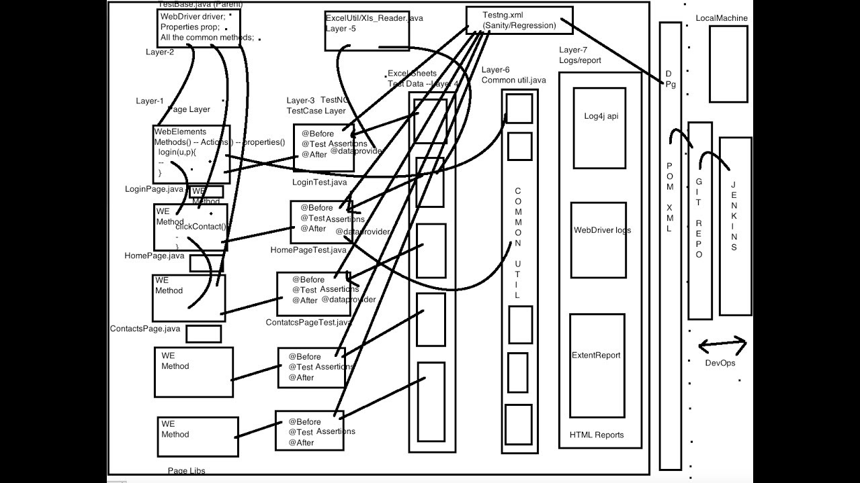

Folder Structure-

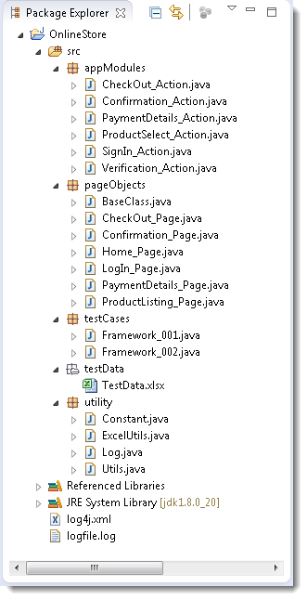

Components/Modules-

* 1. Test Case Standardization (all the test case should follow same approach)
  2. Logging Standardization (common way)
  3. Test data & Configuration Utility (Excel, config file)
  4. Helper/Utility Library (common functionality- Screenshot, login etc)
  5. Test execution engine (POM, TestNG etc)
  6. Reporting Utility.

**Ques - Why do you want to work here? Or Tell me about this company?**

For personal and financial growth (also research about company).

So, definitely will be good exposer and learning for me, as cowbell is going to setup new project from scratch,

**Ques - What are your strength?**

I can easily adjust in new situation, new environment with new people I can say am adaptive by nature.

I do my job with dedication and complete our work in given deadline.

Flexibility- can work in team and individually too.

**Ques - Weakness?**

Sometimes feel bored doing same thing again and again.

Bit lazy about which I am not interested like submit a timesheet, give feedback etc.

**Ques - Why should I hire you?**

Company is looking for the QA profile and I feel I’m the good candidate for this job, and I am sincere with my work and would never let you down in anyway.

* I know in and out of the testing process.
* I can work in functional and non-functional testing.
* I know manual and automation for frontend and backend.
* Good exposer in framework designing.

**Ques - Why you are looking for a job change?**

personal and financial growth. And this is the good company where I can learn and gain more.

**Ques - What are your salary requirement?**

I feel 35-40% increment will be good for me and it will motivate me too, and definitely I’ll add more value in the company.

**Ques - What are your career goal?**

I want to be a tech manager.

**Ques - Do you have any question to ask me?**  
Thanks for asking this question, tell me something about product which I’m going to work if selected and what will be my role and responsibilities.

**Ques - What you mention in Status call/mail?**

* What we did and highlight risks if any.
* Defects if found and the reason.
* What I’m going to do next

**Ques - Project management tool JIRA explain?**

* It is used for **bug tracking.**
* **Project management.**
* **Release planning.**
* **Work coordination**
* **Manage Sprint, Epic, Stories, Backlogs, Defects.**
* **Create different dashboards for project.**
* **We can track how many stories are pending, how many defects are open/closed.**
* **Sprint planning.**

**Assessing the Performance of Your QA and Testing Team?**

**I often hear people talking about Performance Metrics and Key Performance Indicators, but how to define quality engineering productivity exactly? What is it and how to measure? And what are some best practices to increase?**

**How can I evaluate the performance, productivity, and improvement of a Quality Engineer?**

**Is it depending on time spend at the workplace, number of bugs found, certifications etc. or something like that?**

**QA and testing teams are increasingly faced with strict deadlines and pressure to deliver on releases faster.**

* Implementing a comprehensive test strategy that covers all aspects of the software development lifecycle.
* Ensuring that test cases are well defined, documented, and reusable.
* Reviewed Requirements. Number of automated test cases created and executed and Covered Requirements
* Measure the number of bugs found per release.
* Ratio of bugs being reported to bugs being fixed.
* Check if any issue found in production and Severity (bug leakage).
* Number of bugs sent back for clarification.
* Number of bugs over time (not just for one build, but overall ñ shows a broader understanding of mitigating issues early on)
* Time to execute a test cycle.
* Turnaround time for fixing issues (quickness is necessary to keep the project moving forward)
* Number of regression test gaps.
* How stable regression suite is?
* Are they covering all the requirements or not.
* Are they checking negative and edge cases scenarios or not.
* How they are validating which test we have to add into automation suite
* They are following proper testing approaches or not.

managers walk around in the developer pit and talk to people, listen to people, and get a sense of how the team is functioning on a regular basis. This will tell a manager more about his people's performance.

**how to decide which test cases to automate using selenium?**

* Repetitive tests that run for multiple builds.
* Frequently used functionality that introduces high risk conditions.
* Tests that are impossible to perform manually.
* Tests that run on several different hardware or software platforms and configurations.
* Tests that take a lot of effort and time when manual testing.
* Good to execute the cross-platform test cases (like different OS, browsers etc.)
* Test case executed with different set of data.
* Test case executed with different browser.
* Test case executed with different environment.
* Test case executed with complex business logic.
* Test case Involves large amount of data.

**how to review the automation code**

* Should follow test case standardization.
* Follow logging/validation standard.
* Assertion should be there in code.
* Always write dynamic locator.
* All the test cases should be independent to each other.
* All the pages should be independent to each other.
* Don't use hardcoded values.
* Use good level of abstraction.
* Always follow proper design principles: abstraction, encapsulation, inheritance, polymorphism etc.
* Always use dynamic waits.
* Try to run test case multiple times, so you can check the stability.
* Dry run to check functionality.
* Code optimization
* Code duplication
* Do peer review.
* Team review

**What to do when defect is found in production but not during the QA phase?**

* Check for impact on the system. And if is of high severity and high priority, call for a hot fix.
* Do a retrospective meeting and find the root cause for the defect and make sure that we have test scenarios and test cases ready for regression.
* Perform a quick regression on QA Environment for the hot fix and make sure that build is stable, and no new defects introduced because of the defect.
* QA gives approval for moving build to PROD Environment and performs regression testing and signoff for the release.

**How u handle difficult customer issue?**

1st will try to investigate find the root cause of the issue, will check why we missed or is there any env issue, is test covered or not if not will try to add in our regression?

**What if u miss release deadline?**

* It’s very important to provide releases on time.
* But if missed, it's important to communicate the situation transparently.
* Assess the reason for the delay and develop a plan to address it.
* Always keep buffer time for unexpected challenges to avoid missing release deadlines.

**Situation where u agree/disagree with your lead/manager/senior member?**

We can have different opinions and thoughts, but always try to communicate, provide your point of view and hopefully will get some solution.

**What will you do if someone is asking for help in your team?**

Always be ready, that’s the good quality everyone should have.

**Suppose u did some POC and it does not work as planned, how u will handle it?**

Actually, this happen to me, I did POC on **k6**, written lot of performance test for couple of services, integrated with Grafana for visualization and implemented other reporting too and was very good, but team preferred to choose **Locust,** as test was written in Locust, so they wanted to make consistency, but yes, I learnt about performance.

**If u selected, how u will start or first thing u will do?**

Take knowledge of domain/product.

Will go through the Framework, best practices followed.

**Describe when u face unexpected challenge?**

Due to this agile world, things are very fast and sometimes we have to do quick releases, and this is also challenging task. We can talk to my manager/lead, will explain situation, and will get some suggestion and try to handle the situation and learn things.

Sometimes your tests working perfectly fine, and you deployed to production and test started failing and we have to revert the build, that is also challenging task.

**Do u prefer working in team env or individual env?**

Personally, I’ll love to work with the team and that is how we can build good relation, but if requirement is to do work alone than I’m ready to work not an issue.

**Do u prefer weekend/late night work?**

Whenever required will do it but unnecessary will not ask my team to come/work on weekend.

Ex.

* When we need to deliver some important feature
* During release time

**Any difficult working with manager/team/company?**

Communication is the main key here. Sometimes, we can disagree with the team member/manager, so provide your view with proper reason, try to explain the situation but I always had a good relationship with my team and leads.

**how to handle if some member of your team is not working?**

Talk to that person, understand the situation, and try to provide solution and still if he/she is not understating talk to lead/manager politely and ask him/her to help or talk to that person.

**If I’m new in the project and you are a lead and 1 person is not giving his 100% and not providing output, how you will handle?**

1st talk with the person if he/she is interested or not, if not then talk to management and then provide your input.

**What is your daily activity? How you spent your time in your work or how you priorities your work?**

Will check my email, is there any imp email will reply to those, then will check my board and work, will join all required meetings and discussion and priorities my work.

**As a QA, when u most proud of yourself?**

Especially when get good feedback/appreciation from PO/clint, that really motivates me.

**How to priorities your work?**

It is always based on project, if we have to do some critical task 1st, then definitely start with it, if some security trainings required on priority will do that, it’s all about project/product and then rest of the work.

**How do u know if shared KT session in worked perfectly?**

Will try to give some basic task /assignment and ask to do it or may will take reverse KT in positive way and help if required.

**What excite you to coming to work?**

Meet to my team member, discussion about some topic, share knowledge to each other.

**Let suppose you join a company, and you need to optimize framework, what will be your approach? What design principle/oops principle you follow?**

* 1st I’ll try to understand the framework, different folder structure they followed.
* What design pattern is used.
* Following proper coding standard or not.
* Using any hardcoded values.
* Following proper design principle or not.
* Proper logging/reporting handled or not.
* And will try to debug the tests.
* And if any improvement required, definitely will do that.

**What is** **test strategy?**

Test strategy is a high-level plan that outlines the approach, scope, objectives, and techniques for testing a software application or system. It defines how testing will be conducted, what will be tested, how long testing will take, and what resources will be required to carry out the testing activities.

A test strategy usually includes the following elements:

* Objectives: The overall goals and objectives of the testing effort.
* Scope: The areas and components of the application or system that will be tested, and any that will be excluded from testing.
* Test Levels: The various levels of testing (e.g., unit, integration, system, acceptance) that will be performed and the order in which they will be executed.
* Test Types: The different types of testing that will be performed (e.g., functional, performance, security) and the techniques that will be used.
* Test Environment: The hardware and software configurations that will be used for testing.
* Test Data: The data that will be used to test the application or system.
* Test Automation: The degree of automation that will be used for testing.
* Risks and Issues: The risks and issues that could impact the testing effort and how they will be addressed.
* Deliverables: The test deliverables that will be produced (e.g., test plan, test cases, test scripts, test reports).

The test strategy is typically created by the test manager or the testing team and is reviewed and approved by project stakeholders. It provides a roadmap for testing and ensures that testing is conducted in a structured and organized manner, ultimately leading to a high-quality software product.

**What is the difference b/w test strategy vs test planning?**

Test strategy and test planning are both important aspects of software testing, but they have different objectives and focus on different levels of detail.

Test strategy is a high-level document that outlines the overall approach to be taken for testing a software application or system. It provides guidance on the testing objectives, methods, techniques, and tools that will be used. The test strategy document is typically created at the beginning of a project, and it provides a framework for the detailed test planning that follows.

Normally test strategy won’t change.

On the other hand, test planning is a more detailed document that outlines the specific activities, resources, timelines, and deliverables for the testing phase of a project. Test planning takes the high-level guidance provided in the test strategy document and breaks it down into actionable tasks that the testing team will perform. Test planning includes creating test cases, identifying test data, determining testing environments, defining test schedules, and identifying roles and responsibilities.

We can change plan anytime.

In summary, test strategy defines the overall approach to be taken for testing, while test planning is the process of creating a detailed plan that guides the actual testing activities.

**What is test estimation? And different criteria you will consider while doing test estimation.**

Test estimation is the process of predicting the **amount of time, effort, and resources required** to complete testing activities for a particular project or software application. Accurate test estimation is important for effective project planning, resource allocation, and budgeting.

When doing test estimation, there are several criteria that should be considered. These may include:

* Scope of Testing: This involves identifying the scope of testing, which includes the type of testing required such as **functional, non-functional.**
* Test Environment: It is essential to consider the type of test environment required, including **hardware, software, network**, and other related resources that are needed for testing.
* Testing Approach: Determining the testing approach that needs to be taken, which includes identifying the types of testing that are required such as **manual or automated testing.**
* Testing Tools: Identifying the testing tools that need to be used, including testing frameworks, automation tools, and bug tracking tools.
* Test Data: Determining the type of test data required and the amount of time and resources needed to prepare it.
* Skillset: Assessing the skillset and experience of the testing team members and their availability for the testing activities.
* Risk Analysis: Identifying the potential risks that may impact the testing activities, such as unavailability of resources or technical challenges, and taking them into consideration while estimating the testing effort.

By considering these criteria, a more accurate estimation of the time, effort, and resources required for testing can be determined, allowing for effective planning and successful project delivery.

**What tools you used. Pros and cons of those tools? ADO vs Jira.**

**ADO** (Azure DevOps) and **Jira** are two popular project management tools used for software development. Here's a comparison between ADO and Jira:

* Features: Both ADO and Jira offer similar features such as issue tracking, project management, agile planning, and reporting. However, Jira is more flexible and customizable compared to ADO. Jira has a wide range of add-ons and plugins available that allow you to tailor the tool to your specific needs.
* User Interface: Jira has a more intuitive and user-friendly interface compared to ADO. Jira's UI is clean and modern, while ADO can feel a bit cluttered and overwhelming.
* Integration: ADO integrates well with other Microsoft tools such as Visual Studio and Teams. Jira, on the other hand, has a wider range of third-party integrations available, including integrations with popular tools like Slack and GitHub.
* Pricing: ADO and Jira both offer similar pricing models, with a free tier for small teams and paid plans based on the number of users. However, Jira can be more expensive in the long run due to the additional cost of add-ons and plugins.
* Support: Both ADO and Jira offer comprehensive documentation and support options, including online communities, forums, and customer support. However, Jira's community support is more active and helpful compared to ADO.

In summary, both ADO and Jira are excellent tools for software development project management. Your choice will depend on your specific needs and preferences, such as the type of projects you work on, the integrations you need, and the level of customization you require.

**If requirement is changing frequently in agile, so how you will handle this?**

* Prioritize requirements: Identify the most critical requirements and prioritize them accordingly. This will help you to focus your efforts and ensure that the most important features are developed first, even if other requirements change.
* Involve stakeholders: Ensure that stakeholders are involved in the process of managing changes to requirements. This will help to ensure that everyone is on the same page and that any changes are communicated effectively.
* Use version control: Utilize version control tools such as Git to keep track of changes to requirements and code. This will help you to keep a history of changes and roll back to previous versions if necessary.
* Be proactive: Try to anticipate changes and plan for them in advance. This will help to minimize the impact of changes and ensure that your project stays on track.
* Communicate effectively: Keep stakeholders informed of any changes to requirements and communicate regularly about the status of the project. This will help to build trust and ensure that everyone is working towards the same goals.

**If 1 project is released and people who did are not part of the project and you must do regression testing, how you will proceed?**

* Coordinate with BA/PO
* Check production bugs.
* Do exploratory testing and try to understand application.

**How you will review test case?**

* Check all requirements are covered.
* Positive and negative test cases
* Follow some test methods.
* Consider test data also in mind.
* Take care of role as well, we cannot assign all roles to all people.

**How to measure quality matrix?**

* How many bugs raised.
* Is there any bug leakage in production.
* How many tests added into automation suite.
* Customer Satisfaction: Customer satisfaction measures how satisfied customers are with the product. It is a useful metric for measuring the overall quality of the product and can be used to identify areas that require improvement.
* Performance: Performance measures the speed and efficiency of the product. It is a useful metric for measuring the responsiveness of the system and can be used to identify areas that require improvement.
* Security: Security measures the security of the product and its ability to protect against external threats. It is a useful metric for measuring the robustness of the system and can be used to identify areas that require improvement.

**How will you decide testing is done for any feature?**

* 1st go through the requirement properly, understood exactly what the use case is.
* If any doubt in requirements go to BA/PO to confirm.
* Write high level scenarios which covered all the aspect of requirement.
* Write positive/negative/edge-cases test cases.
* Try to decide which test case can be part of regression suite and add the same.
* Verify all test cases manually and using automation whatever we have written.
* If everything looks good, we can go for sign off. And if any defect found then raise the same and assign to respective person, link to respective ticket, and wait till finish and once developed verify feature again.

**Let suppose you have completely big new requirement/feature coming and you must estimate time for testing, how you will measure?**

When estimating the time required for testing a new feature or requirement, it's important to consider a number of factors that can impact the testing effort. Here are some steps you can follow to estimate the testing effort for a big new requirement:

* Understand the Requirements: The first step is to have a clear understanding of the requirements. Review the requirements and make sure that they are clear, unambiguous, and testable. If there are any ambiguities or gaps in the requirements, work with the development team to clarify them.
* Determine the Scope of Testing: Determine the scope of testing required for the new requirement. Will it require functional testing, integration testing, regression testing, or all of the above like non-functional? This will help you to estimate the overall effort required for testing.
* Identify Test Cases: Identify the test cases that will be required to test the new requirement. This will involve creating new test cases, as well as modifying existing test cases as necessary.
* Estimate Test Execution Time: Estimate the time required to execute the test cases. This will depend on the complexity of the requirement, the number of test cases, and the execution time for each test case.
* Estimate Bug Fixing Time: Estimate the time required to fix any defects identified during testing. This will depend on the severity of the defects and the complexity of the code.
* Consider Environment and Infrastructure: Consider the environment and infrastructure required for testing. Will you need additional hardware, software, or testing tools? This will impact the overall effort required for testing.
* Consider Other Factors: Consider other factors that can impact the testing effort, such as the availability of resources, the experience of the testing team, and the level of automation.

Based on these factors, you can estimate the time required for testing the new requirement. It's important to keep in mind that testing estimates are just that - estimates. The actual time required for testing may vary based on a number of factors, so it's important to review and adjust your estimates as necessary throughout the testing process.

**Why you choose different framework for UI and API?**

In our project we followed microservice architecture and multiple teams are using same API framework for their API automation, that’s the reason we written separate framework for API and UI.

**What design pattern you are using in your framework and apart from design pattern what are the important library you use in your framework?**

POM and explain other tools and technology used.

**How will you do the Risk analysis?**

Risk analysis is a crucial step in the software development process, and it involves identifying potential risks and assessing the likelihood and impact of those risks. Here's a general process for conducting a risk analysis:

* Identify Risks: Start by identifying potential risks that could impact the software development process. These could be risks related to project scope, technology, resources, schedule, or any other factors that could affect the success of the project.
* Evaluate Risks: Evaluate each identified risk to determine the likelihood of the risk occurring and the potential impact it would have on the project. Consider both the severity and the frequency of the risk, as well as any dependencies or interrelationships between risks.
* Prioritize Risks: Prioritize the risks based on their likelihood and impact. High priority risks are those that are likely to occur and would have a significant impact on the project.
* Mitigate Risks: Develop a plan for mitigating each identified risk. This may involve taking actions to reduce the likelihood of the risk occurring, or developing contingency plans to minimize the impact of the risk if it does occur.
* Monitor Risks: Monitor the risks throughout the project to ensure that the risk management plan is effective. Adjust the plan as necessary if new risks are identified or if existing risks change.

Some common techniques for risk analysis include brainstorming, SWOT(strategic planning tool) analysis. It's important to involve key stakeholders in the risk analysis process to ensure that all potential risks are identified and that the risk management plan is effective.

**What is the use of base64?**

Base64 encoding is used in many applications, including:

* Email Attachments: Base64 encoding is commonly used to send email attachments that contain binary data, such as images or documents. The binary data is first encoded using Base64 and then included in the email message as an ASCII string.
* Data Transmission: Base64 encoding is often used to transmit binary data over channels that can only handle text data, such as HTTP requests or websockets.
* Encryption: Base64 encoding is sometimes used as part of encryption schemes to encode encrypted data so that it can be transmitted safely over the internet.
* Data Storage: Base64 encoding can be used to store binary data in a text-based database or file format, such as JSON or XML.

**When will you choose TDD and when to choose BDD?**

BDD : when everyone wants to involve in writing feature file or may be feature file provided by stackholder or PO, then BDD is good approach

But if you or your QA team only have to wright everything, they why to take this better to use TDD approach.

**How to showcase your knowledge in interview?**

Share screen and if possible, show repo which you created, how u r executing test via pipeline and all.

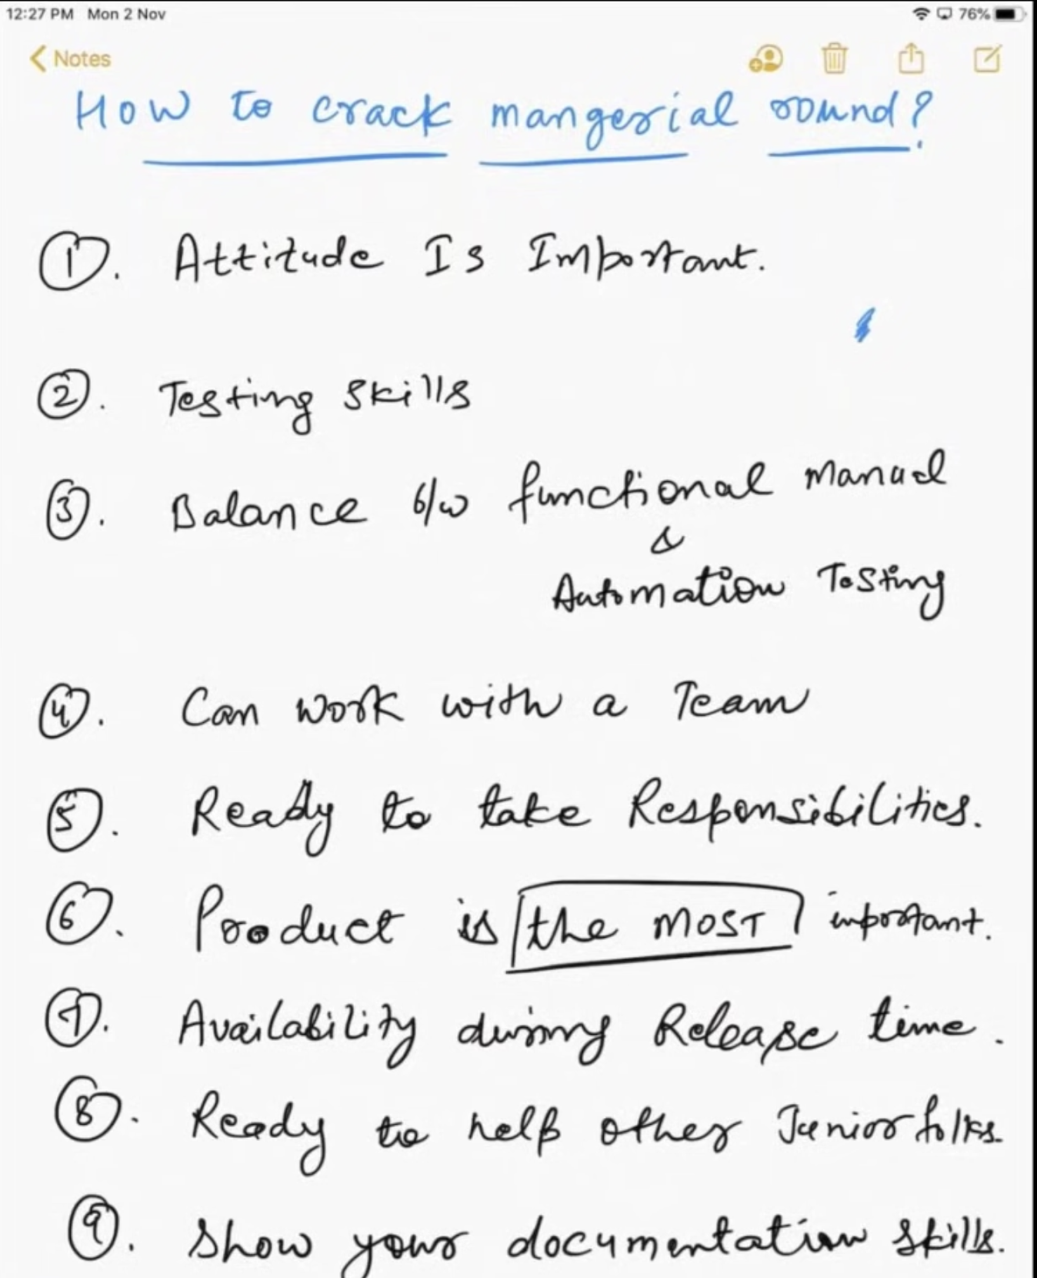

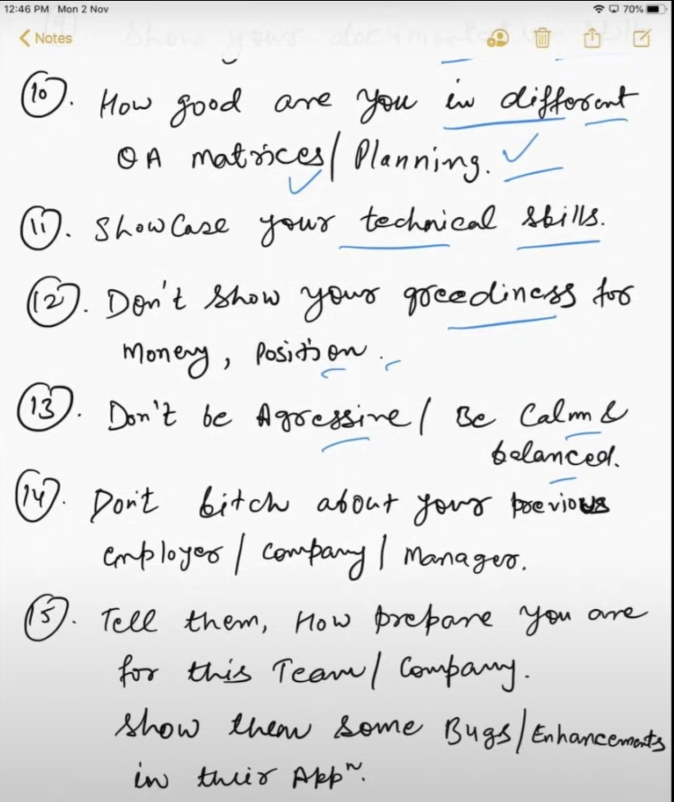 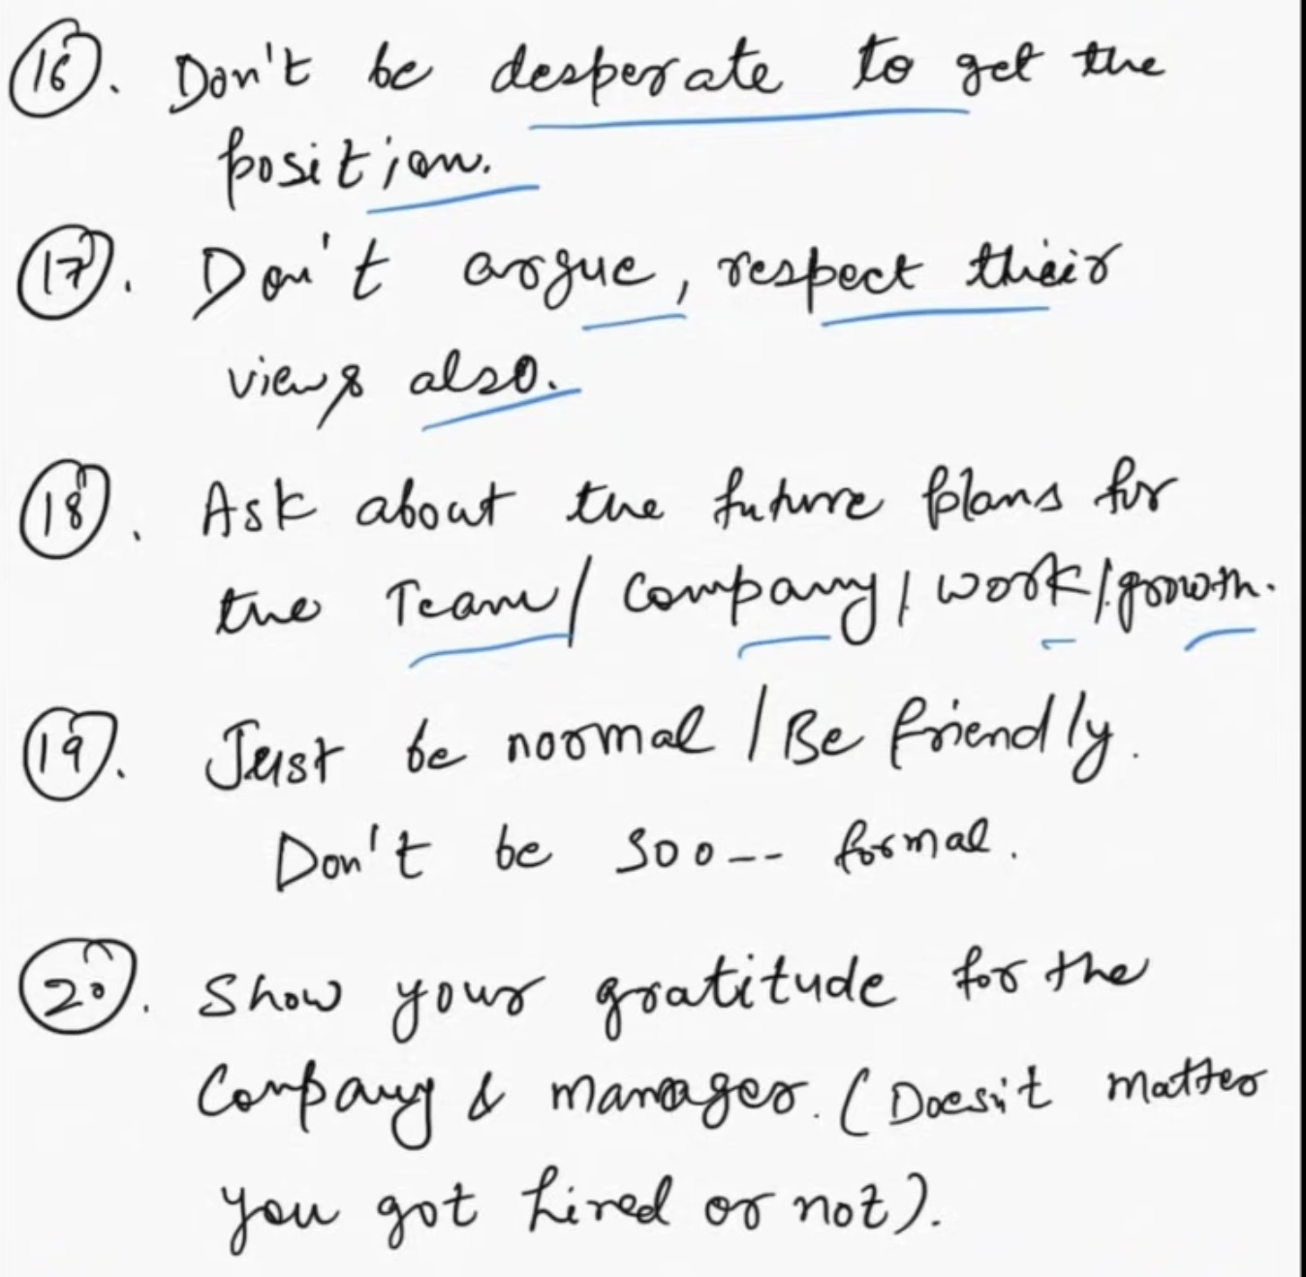

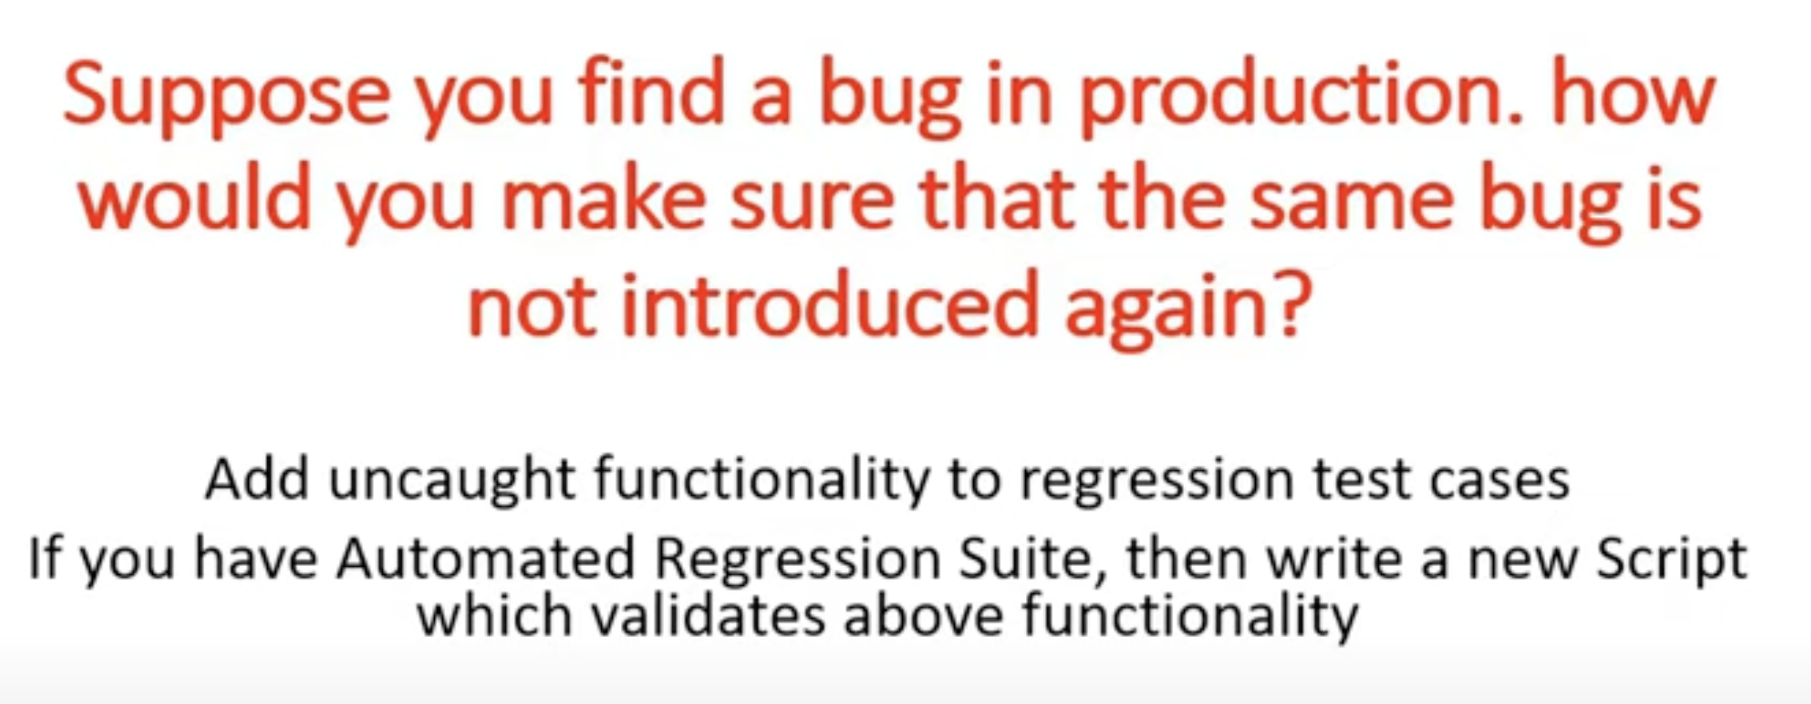

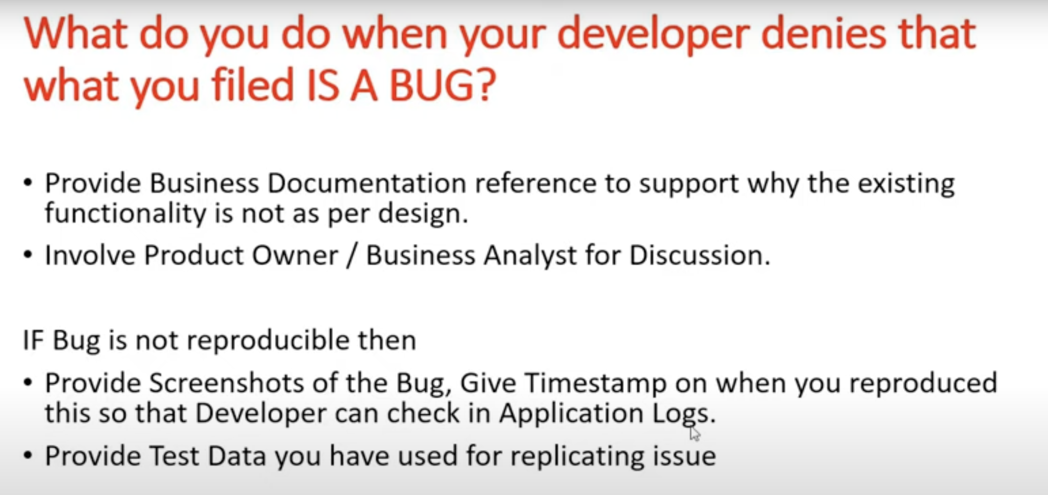

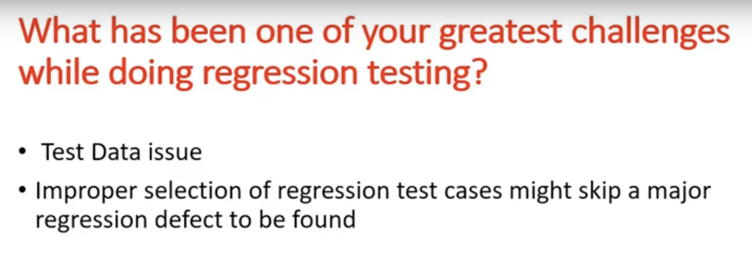

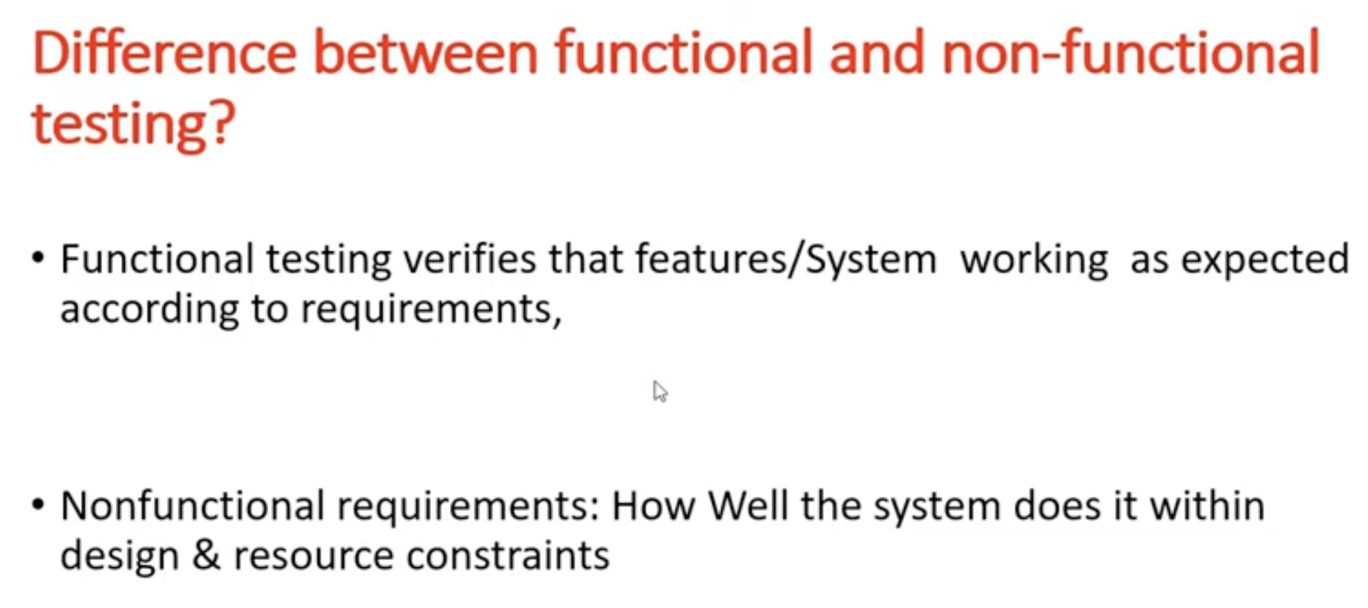

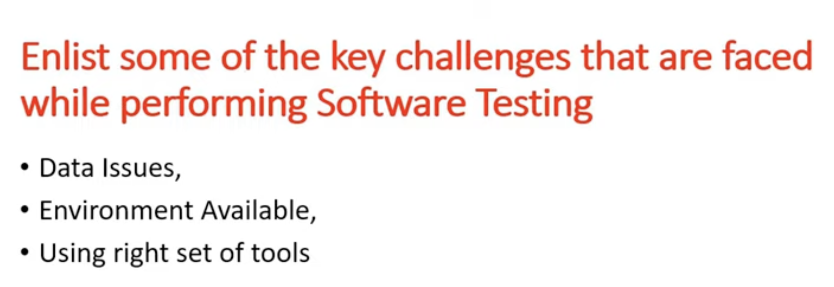

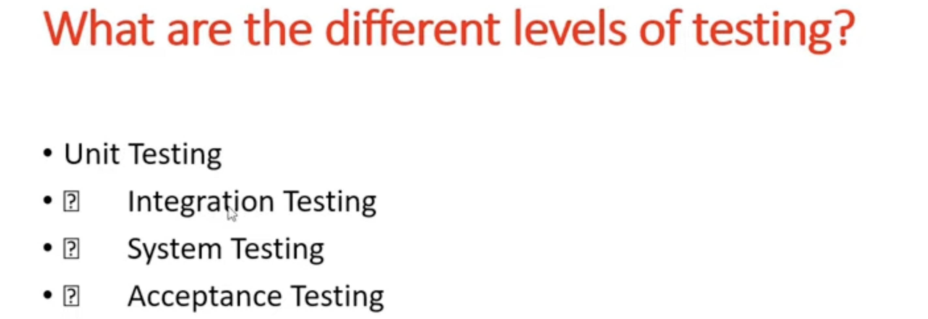

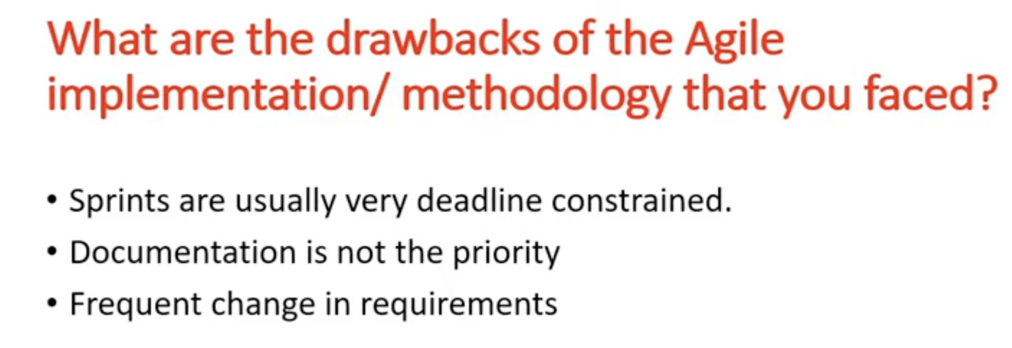

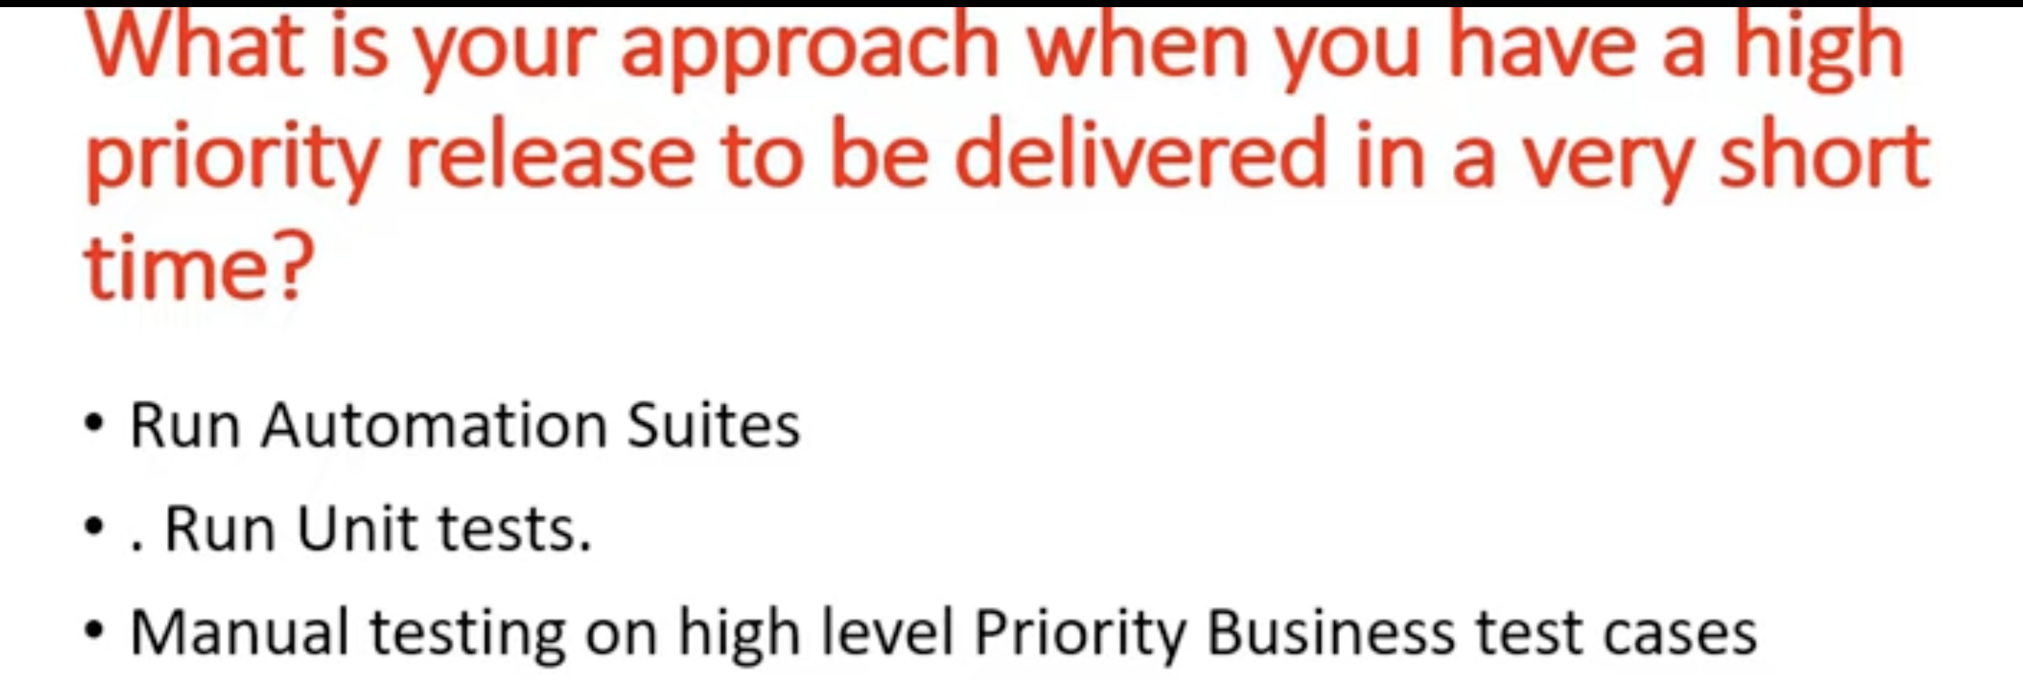

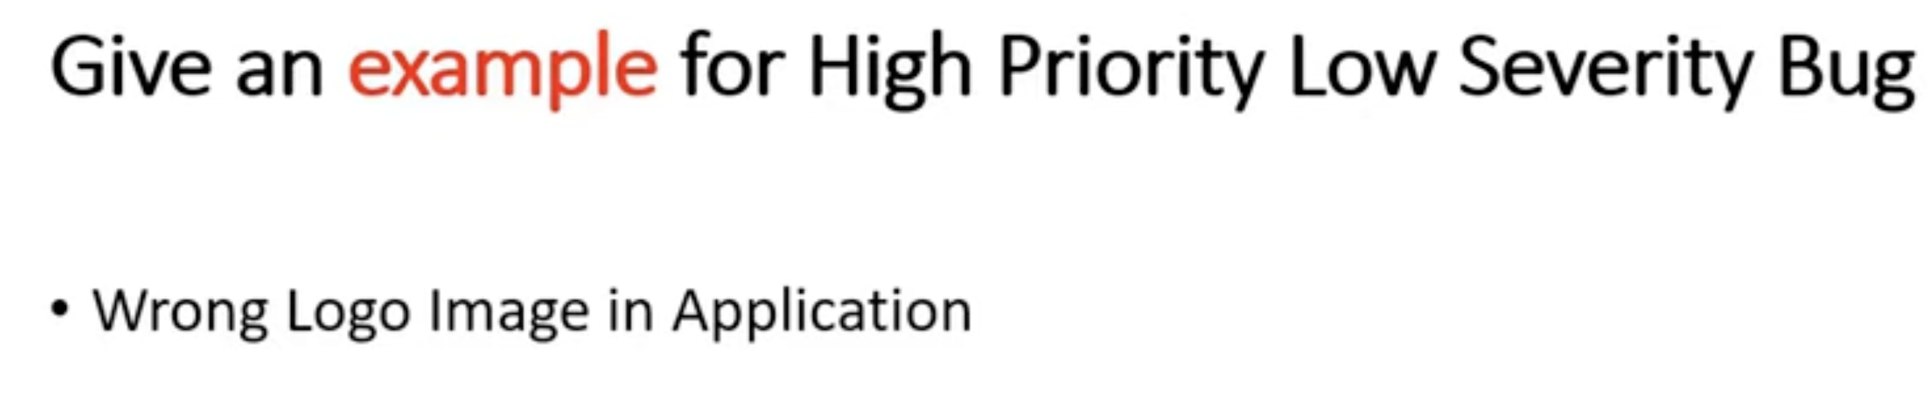

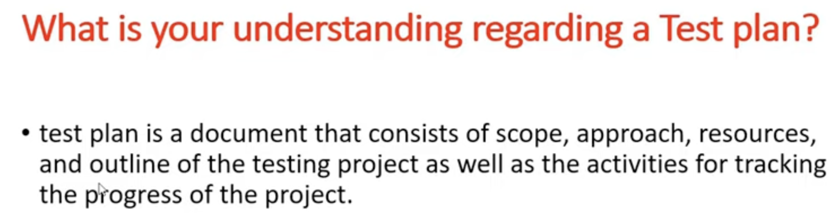

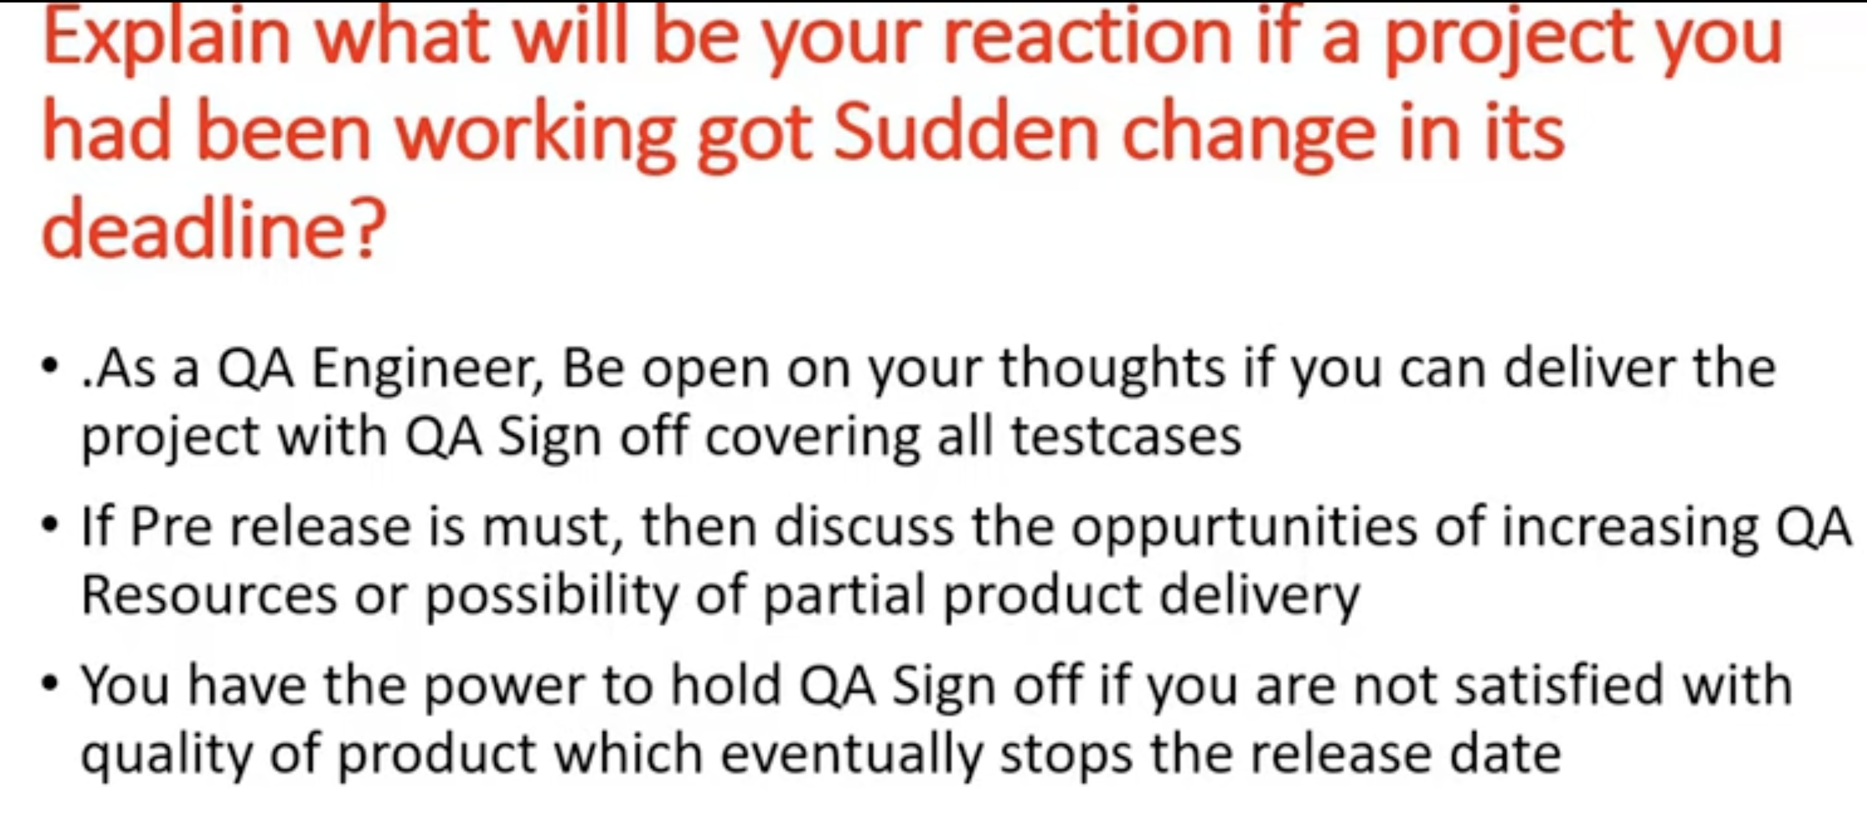

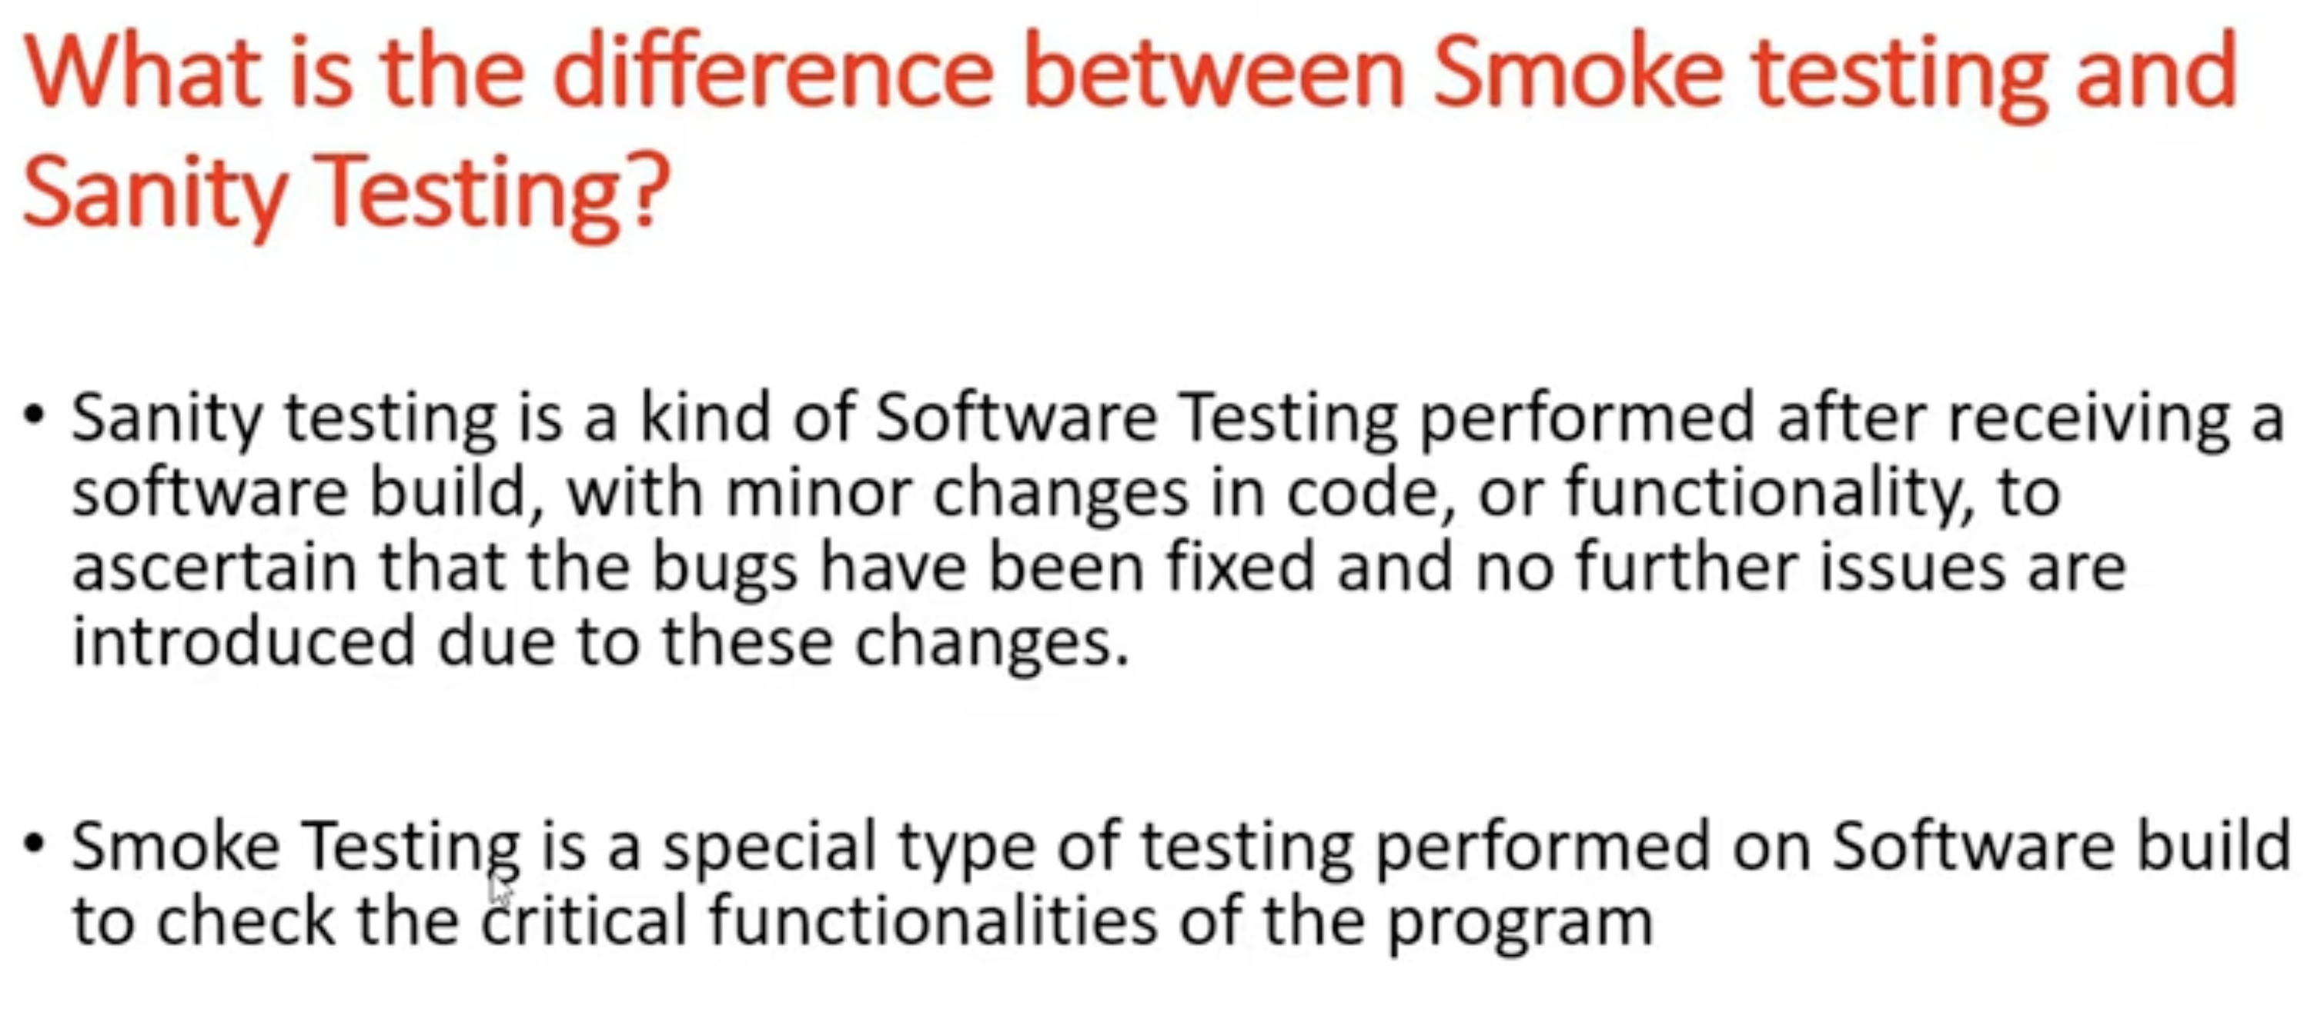



* Related functionality.
* Changed functionality.

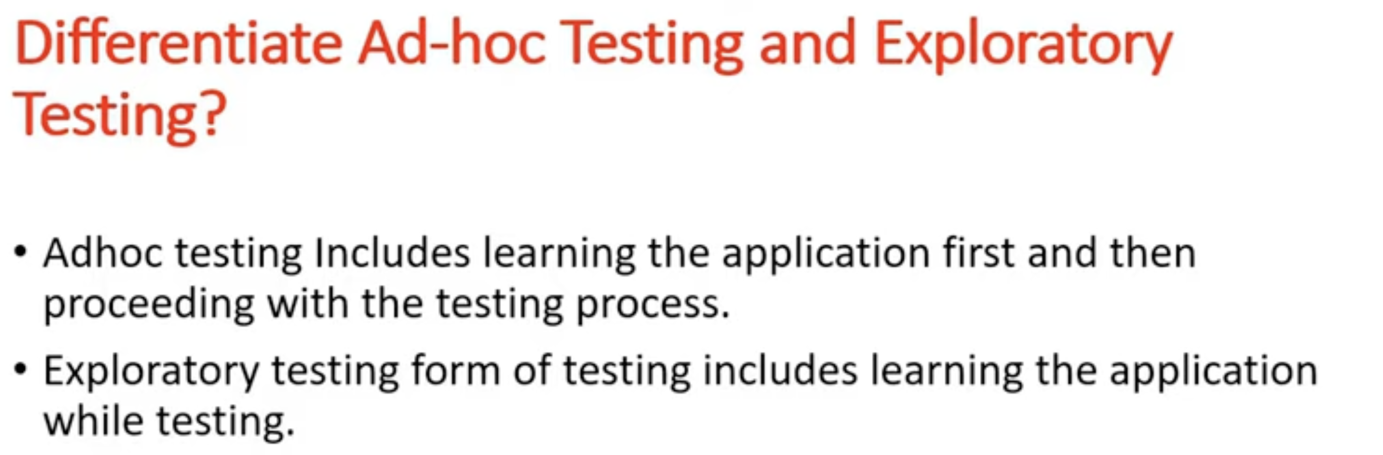

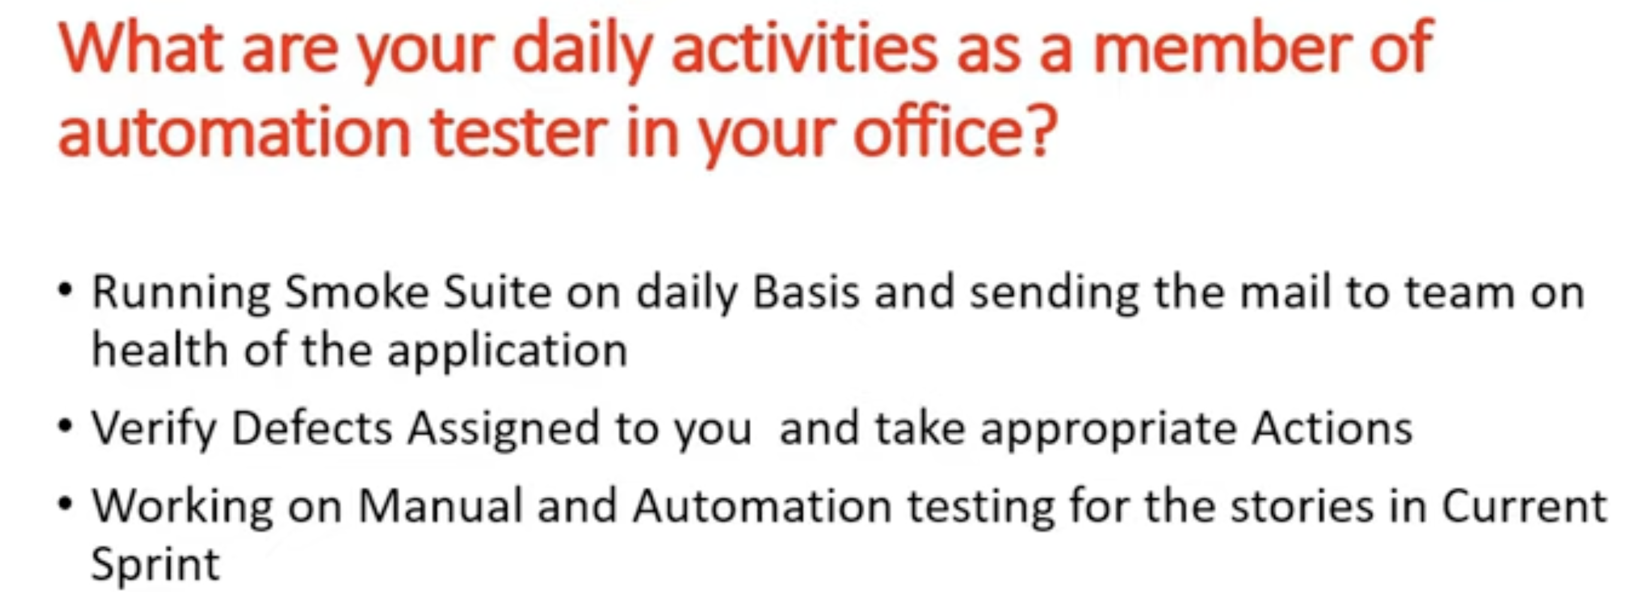

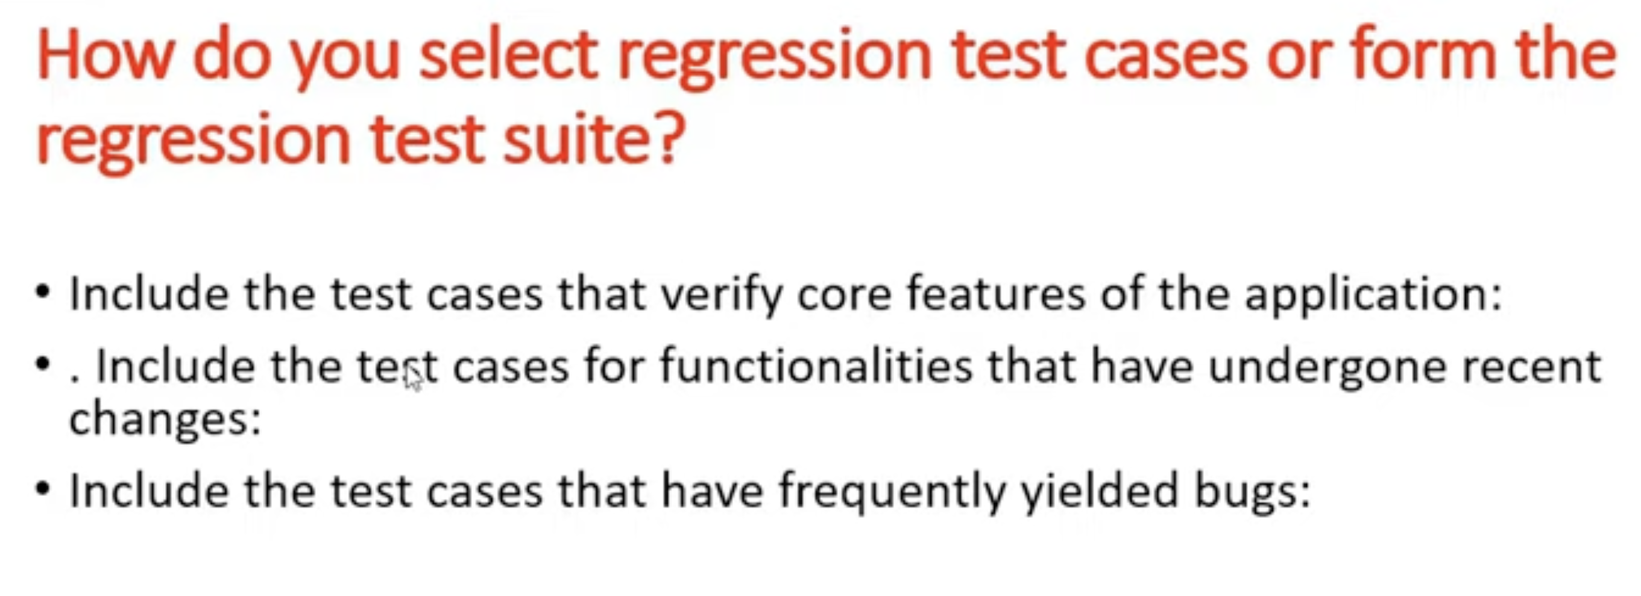

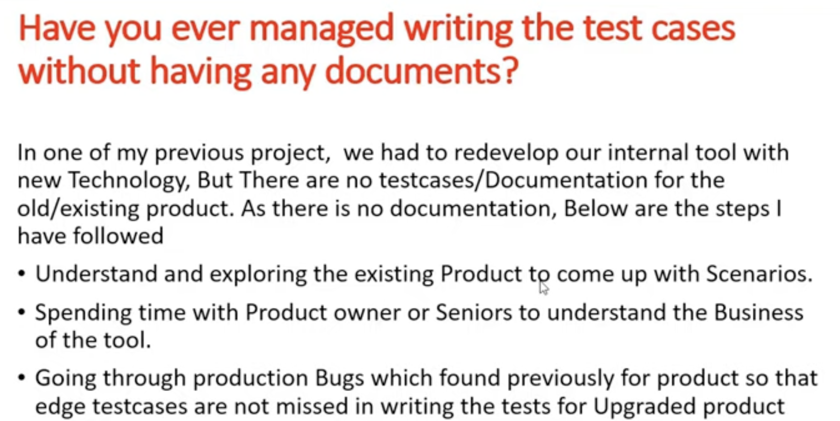

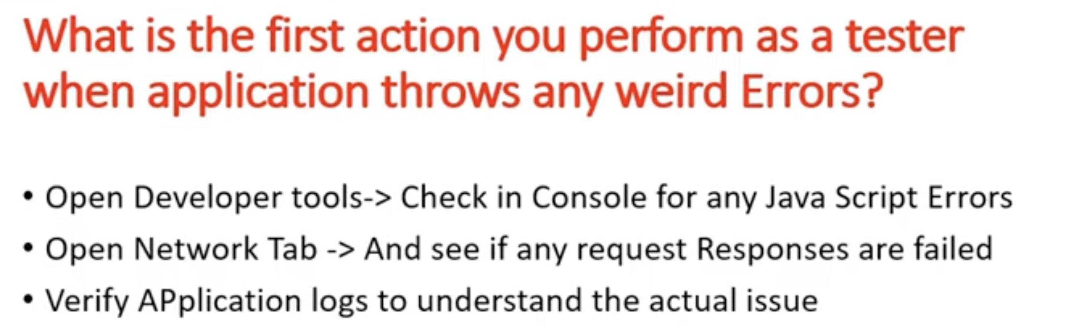

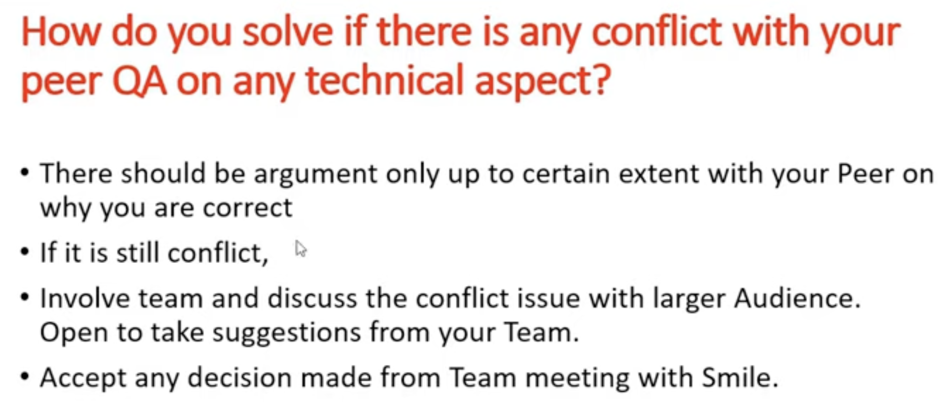 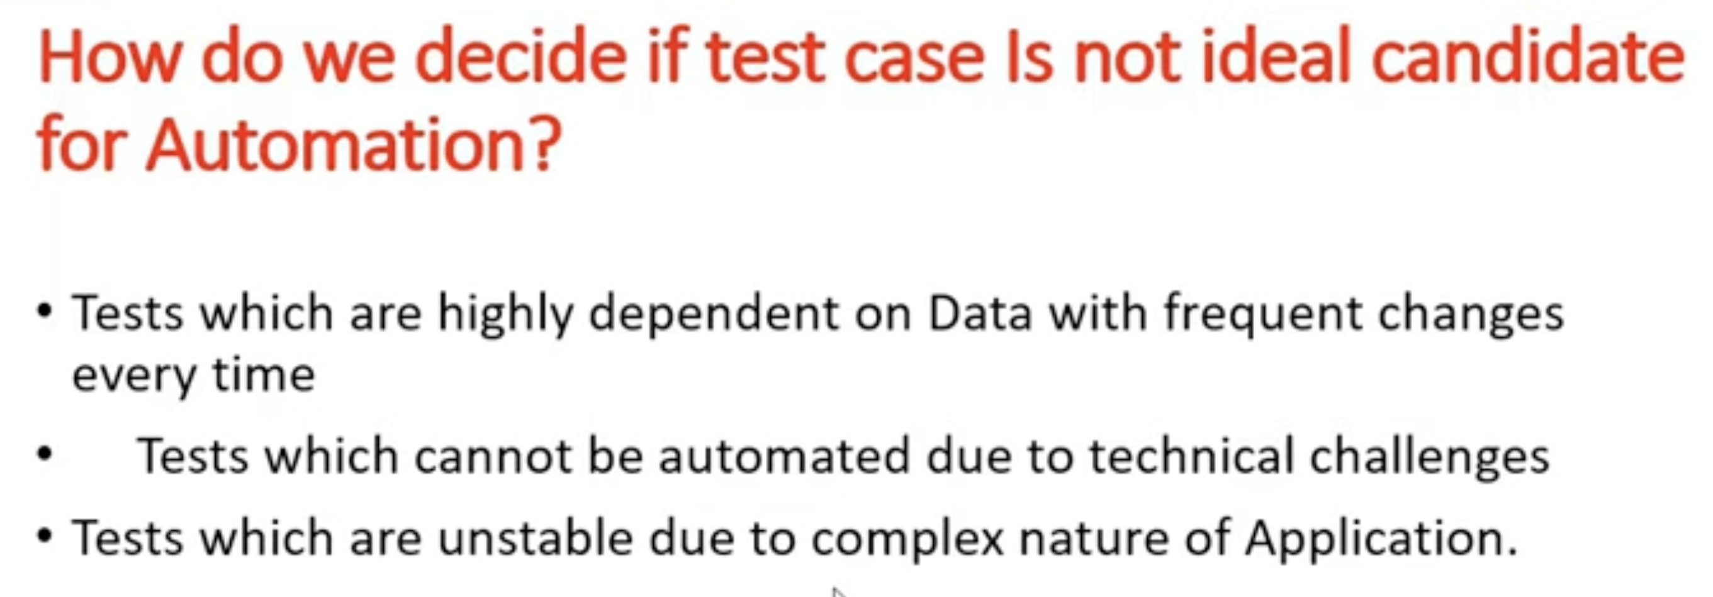 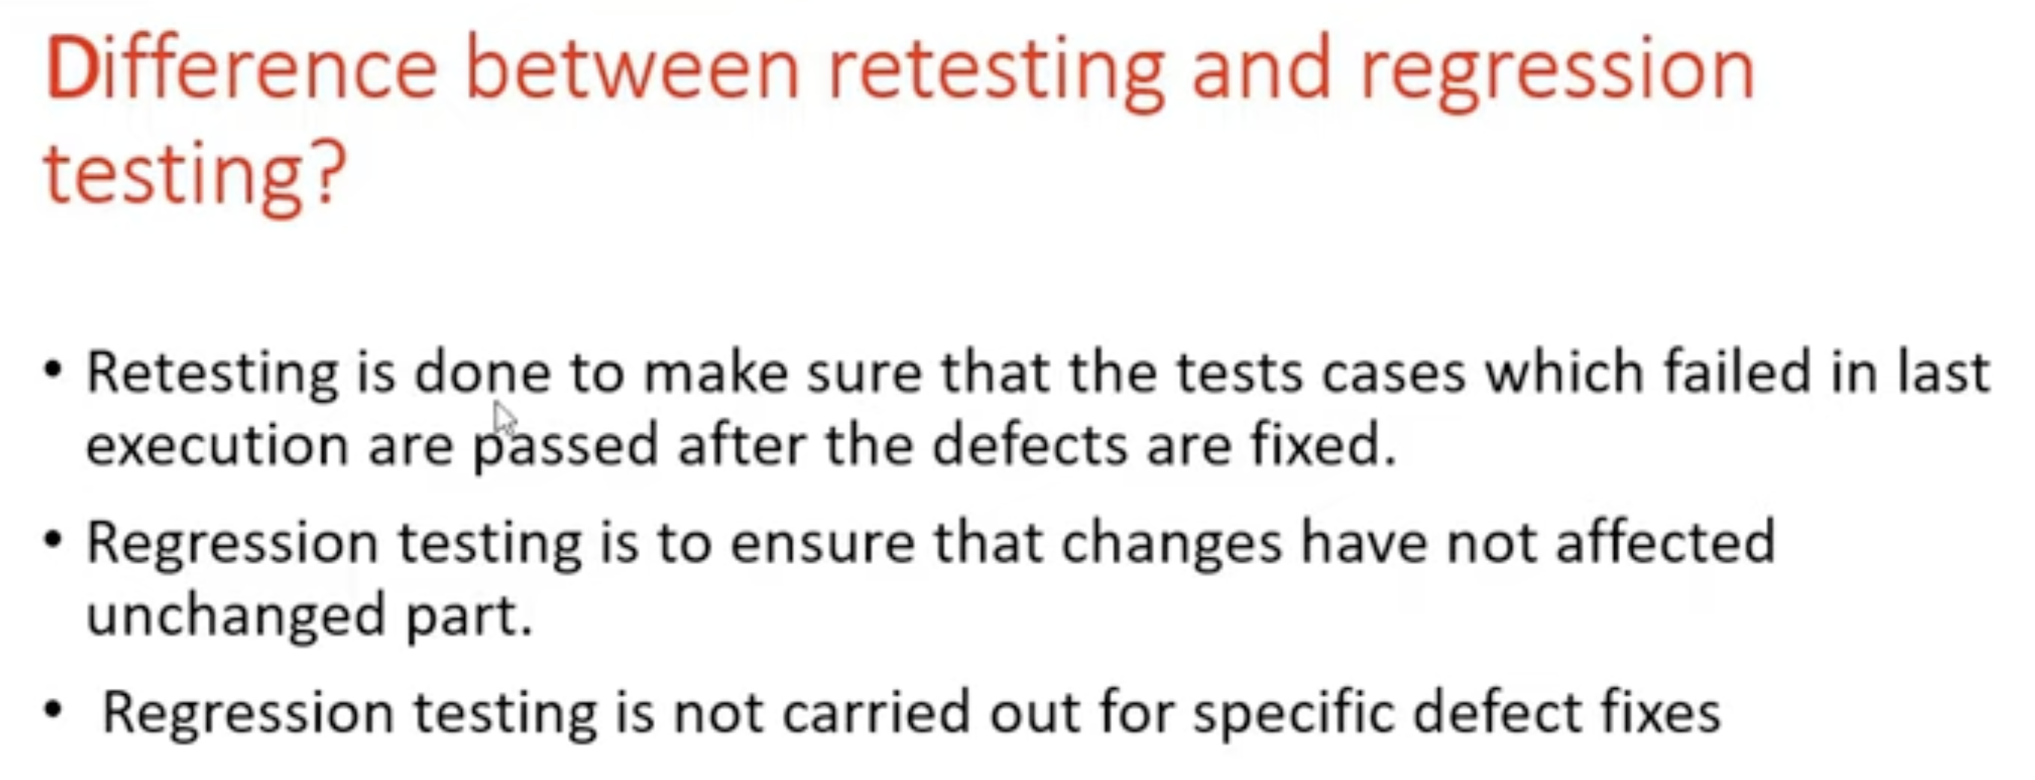



We raised one security issue and dev updated Jar, but bcs of new version, some of our major functionality started creating issues, job getting stuck in Queue state and not gng to complete/failed.

